Strictly embargoed until 4.30pm Wednesday 24th January

The BRIT Awards 2024 with Mastercard

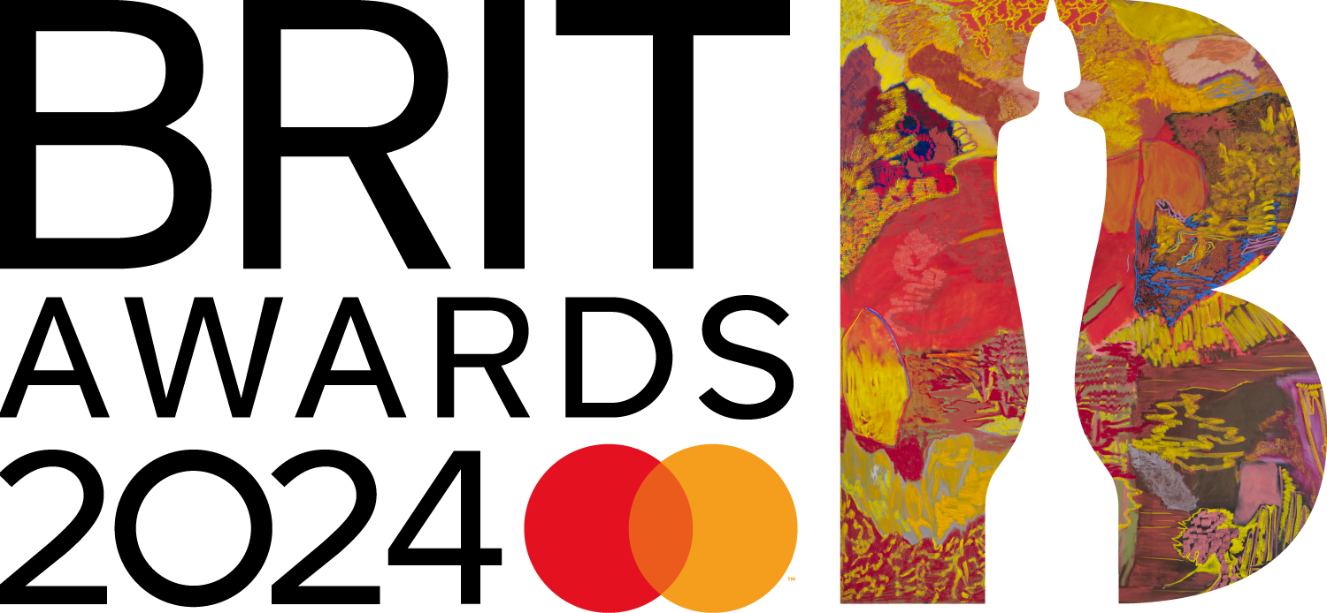

2024 BRIT Nominations led by RAYE, with a monumental seven nominations
including Artist of the Year and Mastercard Album of the Year
breaking the record for the most nominations by a single artist in any one year

Dua Lipa nominated for three awards -
and is the first artist to be confirmed to perform on the main show

Central Cee and J Hus nominated for four apiece

Blur, Calvin Harris, Dave, Little Simz, Olivia Dean, Young Fathers all up for three awards

Double nominees include Fred again.., Mahalia, PinkPantheress, SZA,
Olivia Rodrigo, Miley Cyrus, Yussef Dayes

The Rolling Stones nominated for their first BRIT in over a decade

More than half (55%) of the 2024 BRITs nominations feature women –
either as a solo artist or as part of an all-woman group

Wednesday 24th January - The nominations for this year’s BRIT Awards with Mastercard were this afternoon revealed in ‘Bring on The BRITs with Mastercard: The 2024 Nominations’, a 30 minute special streamed across the BRITs' official Instagram and Facebook. Host Yinka Bokinni took viewers through the category shortlists, with a few guest appearances from nominated artists and fellow broadcaster Jack Saunders.

The winners - who will each receive an award designed this year by visual artist and painter Rachel Jones - will be revealed at The BRIT Awards on Saturday 2nd March at The O2 arena, broadcast live on ITV1 and ITVX.

For 2024, The BRITs increased the number of nominees for both Artist of the Year and International Artist of the Year from five to ten, a change aimed at improving representation and inclusion. More than half (55%) of the 2024 BRITs nominations feature women – either as a solo artist or as part of an all-woman group. This figure rises to 57% if you also include women in mixed gender groups.

A new genre award category R&B Act has been introduced for 2024, which along with Alternative/Rock Act, Dance Act, Pop Act, Hip Hop/Grime/Rap Act, collectively showcase the versatility, creativity and diverse styles of music in the UK.

The winners of the genre awards will be determined by a public vote exclusively through Instagram, which will open on Thursday 1st February at 12 noon and close on Thursday 15th February at 6pm.

To vote, fans can either head to the BRITs page on Instagram (@BRITs), and comment on the category Reel of their choice using an artist specific hashtag, or by creating a Reel and using the @BRITs tag, and the artist specific # in the caption. Further information on the vote will be announced soon.

Taking the title of the most nominated artist in a single BRITs year, RAYE leads the charge with an incredible seven nominations in total – a first by any artist since The BRITs began in 1977, eclipsing the record to date of six held by Gorillaz (2002), Craig David (2001) and by Robbie Williams (1999). In recognition of what has been a spectacular year for the independent artist, singer/songwriter and BRIT School graduate, she is nominated for: Artist of the Year, Mastercard Album of the Year, Best New Artist, Pop Act, R&B Act, and receives two nominations in Song of the Year with Mastercard.

Four-time BRIT winner Dua Lipa receives three nominations this year; for Artist of the Year, Pop Act and Song of the Year with Mastercard, and is the first artist to be confirmed to perform at the main show on 2nd March. Dua Lipa last performed at The BRITs in 2021.

Central Cee and J Hus both receive four nominations for this year’s BRIT Awards. Both are up for Hip Hop/Rap/Grime, Artist of the Year and Song of the Year with Mastercard - with Central Cee nominated twice in this category.

Along with RAYE, Dua Lipa, Central Cee and J Hus, this year’s Artist of the Year category also sees nominations for Arlo Parks, Dave, Fred again.., Jessie Ware, Little Simz and Olivia Dean.

J Hus is also nominated for Mastercard Album of the Year, along with Blur, Little Simz and Young Fathers who each receive three nominations in total. Also up for three awards at the 2024 ceremony are Calvin Harris, Dave and Olivia Dean.

The International Artist of the Year category is another immense showdown of global talent; with nominees Asake, Burna Boy, Caroline Polachek, CMAT, Kylie Minogue, Lana Del Rey, Olivia Rodrigo, SZA and Taylor Swift - with Olivia, Miley and SZA all nominated in International Song of the Year as well.

Other artists up for more than one award include: Fred again.., Mahalia, PinkPantheress and Yussef Dayes.

2024 also sees the first BRIT nomination for The Rolling Stones in over a decade; having been nominated four times previously in 1977, 1995, 1996 and 2013.

Other artists nominated for a 2024 BRIT award include: Becky Hill, Billie Eilish, Casisdead, Charli XCX, Doja Cat, Ed Sheeran, Foo Fighters, Lewis Capaldi, Noah Kahan, Paramore, Peggy Gou, Rema, Stormzy, Tate McRae and Tyla.

In December, The BRITs announced the winner of the 2024 Rising Star supported by BBC Radio 1 award as The Last Dinner Party. They join the list of incredible artists who have won the award in previous years including Adele, Florence + The Machine, Sam Smith, Ellie Goulding, Emeli Sandé, Griff, and last year’s winner, FLO.

The winners of Songwriter of the Year and Producer of the Year will be revealed over the coming weeks, along with other show announcements.

Damian Christian, Managing Director and President of Promotions at Atlantic Records (part of Warner Music UK) and Chair of the BRIT Committee for 2024 said: “This year's BRIT nominees really highlight the incredible breadth and diversity within British music. From breaking artists to returning greats, and with artists spanning so many genres, this year's shortlist really feels like it has it all. I'd like to congratulate RAYE on her record-breaking seven nominations, as well as every other artist up for an award - I hope to see you all on the night!"

Dr. Jo Twist OBE, BPI Chief Executive and YolanDa Brown OBE DL, BPI Chair said in a joint statement: “We congratulate all the nominees on their deserved recognition of a brilliant year in music, and in particular RAYE on her exceptional achievement of a record seven nominations, underlining a truly outstanding 12 months for her. It’s also wonderful that women overall have performed so strongly across so many of the awards categories. We shared in last year’s disappointment that women were not represented in the British Artist of the Year nominations, and it’s heartening to see such a strong showing in the BRITs 2024 nominations. With such an exciting new generation of diverse talent coming through, we hope and will continue to work towards more balanced representation increasingly becoming the norm rather than the exception.”

The BRITs Voting Academy, responsible for determining the shortlists and the overall winners for The BRIT Awards (bar Rising Star, Songwriter and Producer awards which are voted on or decided by separate panels), is refreshed annually, drawing on updated member data, to ensure relevance and diversity across its participants. The Voting Academy is composed of approx. 1300 individuals drawn from across the music industry, including artists, managers, media, producers, publishers, record labels, retailers and more. For 2024, The Voting Academy achieved a balanced split of men and women and included a number of members who identified as non binary or who preferred not to specify their gender, whilst a quarter of its members identified as Black, Asian or ethnic minority background. The Academy and the voting process is overseen by Civica – an independent voting scrutineer.

This year, The BRITs are teaming up with Music Declares Emergency to amplify the NO MUSIC ON A DEAD PLANET campaign. This campaign has the support of thousands of artists including some of the biggest names in music and this new partnership with The BRITs will give music fans a way to get involved in positive climate action. Music fans can get involved now by heading to nomusiconadeadplanet.org to sign up for monthly climate action challenges and music giveaways!

The BRIT Awards 2024 with Mastercard will take place on Saturday 2nd March - once again back in a primetime Saturday night slot - and will broadcast live on ITV1 and ITVX - from The O2 arena.

Mastercard returns as headline partner of The BRIT Awards for the 26th year, bringing cardholders closer to their passion for music through a range of BRITs experiences. Mastercard continues to partner with the BRIT School to support and celebrate the next generation of creative talent.

------

www.brits.co.uk
@BRITs (Twitter, Facebook Instagram, YouTube, TikTok)

For further information on The BRITs, please contact:
Press/Online – DawBell
Stuart Bell/Richard Dawes/Kate Etteridge/Holly Appleton
Stuart.bell@dawbell.com / 07931501495
Richard.dawes@dawbell.com / 07931 501 924
kate.etteridge@dawbell.com / 07786548850
holly.appleton@dawbell.com / 07891997704

Notes to Editors
About The BRIT Trust www.brittrust.co.uk

The BRIT Trust is the music industry’s charity, with a mission to improve lives through the power of music and the creative arts. It is funded in large part through monies raised annually by The BRIT Awards and the Music Industry Trusts (MITS) Award. Since its founding by UK record labels and the BPI in 1989, the Trust has distributed over £28 million to a broad range of progressive charities and causes around the UK that promote education and wellbeing through music, with over half this amount going to The BRIT School, the UK’s leading performing and creative arts school that is free to attend, and Nordoff and Robbins, the UK’s largest music therapy provider. Other charities supported include Mind, to promote good mental health in schools, the music industry and the workplace; Music Support, the addictions and mental health charity; East London Arts & Music (ELAM), the free school creative arts sixth form; and Key4Life, which seeks to help young men in prison, or who are at risk of ending up there, a way out from a life of crime by drawing on their passion for music. More recently causes such as Come Play With Me, Heart ‘n’ Soul, Independent Venue Week, Liam Colgan Music Fund, Not Saints, and Sing Inside have been supported - you can learn more about their work and that of the BRIT Trust by reading The BRIT Trust Diaries, published exclusively by Music Week here.

About Mastercard (NYSE: MA) www.mastercard.com
Mastercard is a global technology company in the payments industry. Our mission is to connect and power an inclusive, digital economy that benefits everyone, everywhere by making transactions safe, simple, smart and accessible. Using secure data and networks, partnerships and passion, our innovations and solutions help individuals, financial institutions, governments and businesses realize their greatest potential. With connections across more than 210 countries and territories, we are building a sustainable world that unlocks priceless possibilities for all.

About ITV
In Media & Entertainment ITV commissions brilliant programmes in a full range of genres, including a wealth of entertainment formats, high-quality drama, must-watch sporting events, impactful factual and award-winning current affairs and journalism. This is made available to audiences through our family of channels, the biggest commercial network in the UK, and through ITVX, the new ad-funded, free streaming home for ITV and new programme premieres. ITVX also features a subscription option, for audiences who want to watch ad-free, and get access to BritBox UK.

About The O₂
The O₂ is the world’s most popular live entertainment, leisure, and retail destination, and has been visited by over 100 million people since opening in 2007. Playing host to over 300 events a year, The O₂ is home to The O₂ arena which was recognised as Billboard’s ‘Venue of the Decade’ for the 2020’s, and ‘Venue of the Year’ at the 2022 LIVE Awards, as well as club-sized music venue indigo at The O₂.

A full day-out destination, there’s plenty to explore at The O₂ including the award-winning roofwalk attraction, Up at The O₂; Outlet Shopping at The O_{2,} with up to 70% off RRP on over 60 designer brands including adidas, Calvin Klein, Levi’s, Nike, Superdry, and Tommy Hilfiger; interactive football experience TOCA Social; London’s first iFLY Indoor Skydiving; ‘gaming battleground’ BOOM BATTLE BAR; Cineworld, London’s largest cinema with 19 screens; the 12-lane boutique Hollywood Bowl; Oxygen Freejumping trampoline park; immersive dining experience Mamma Mia! The Party; interactive photo experience Selfie Factory, and over 30 bars and restaurants. Conveniently located just 15 minutes from Central London, The O₂ is easily accessible via road, tube, bus, or boat.

The O₂ arena and Up at The O₂ are owned and operated by AEG Europe. The Entertainment District and Outlet Shopping at The O₂ are owned and operated by a joint venture between AEG Europe and Crosstree Real Estate.

For the latest updates, follow us on Instagram, Facebook or Twitter.

About NO MUSIC ON A DEAD PLANET

The NO MUSIC ON A DEAD PLANET Movement is a global movement of musicians and music lovers coming together to take action on climate. Fans can sign up to find ways to get involved through monthly climate action challenges, volunteering opportunities and prize giveaways. You can find more information here: nomusiconadeadplanet.org

