The BRIT Awards 2024 with Mastercard

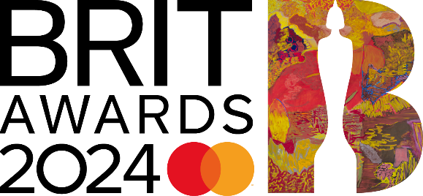
Broadcast live on ITV1 and ITVX

The Last Dinner Party
announced as winners of BRITs Rising Star award
supported by BBC Radio 1

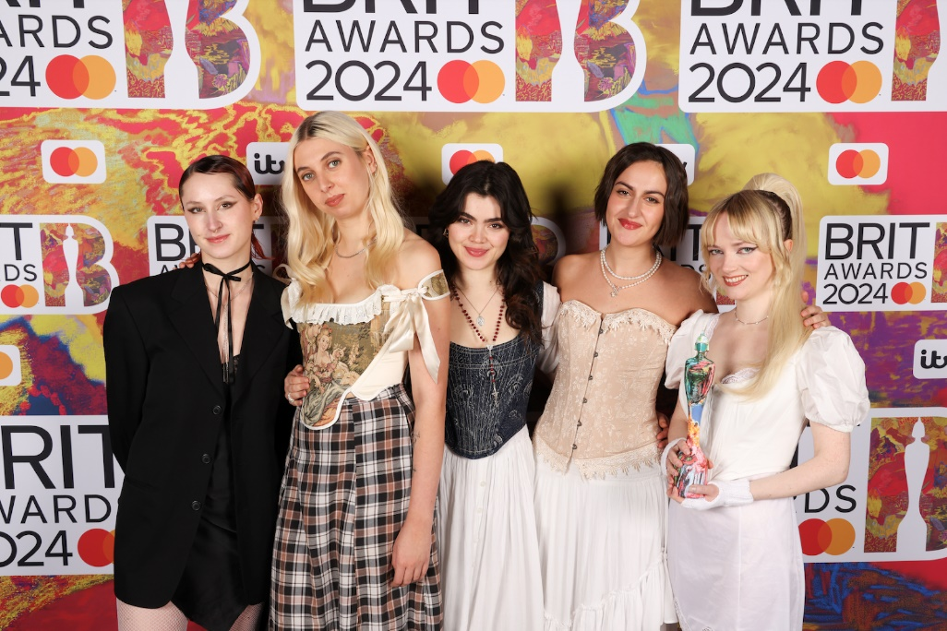
Photo credit: John Marshall/JMEnternational

The BRIT Awards with Mastercard 2024
Saturday 2nd March – at The O2 arena on ITV1 and ITVX

Thursday 7th December - The BRIT Awards 2024 with Mastercard have today announced that The Last Dinner Party are the winners of the prestigious BRITs Rising Star award supported by BBC Radio 1. The news was revealed by Clara Amfo on her BBC Radio 1 Future Sounds show.

The Last Dinner Party said: “We are so proud beyond measure to have won the BRITs Rising Star. It’s an honour to achieve something so iconic so early on in our career and we can only hope to keep making music that connects with all the incredible people who have listened to and supported us so far. Thank you!”

At the turn of the year, The Last Dinner Party was little more than a new name being shared by those that had inadvertently caught them live. Great songs, strong aesthetic. Five women writing and performing melody-rich, guitar-heavy leftfield indie-rock dramas. Spending much of 2022 adding to their older songs, writing new ones, road-testing them all, and taking the fruits of that process into the studio to record with producer James Ford, it wasn’t until April 2023 that the band released the instantly more-ish Nothing Matters and seemingly everyone had quickly formed an opinion on them. It was an introduction that took the online world by storm, and yet behind all the excitement and narrative was a fantastically confident song by a band doing it the old-fashioned way, out on the road. By July, The Last Dinner Party had released Sinner, another gloriously infectious, leftfield pop epic that fuelled the now fully-formed zeitgeist and set the band up for a Summer packing tents at festivals across the UK and Europe. It was a breakthrough Summer for one of the most talked about new British acts in years, delivering on all that early promise emphatically. The crunching snarl of My Lady Of Mercy confidently compounded all the buzz and excitement. And as they line up their debut album, Prelude To Ecstasy, for February 2024, everyone is staking a seat at the table for The Last Dinner Party.

Caity Baser and ELAM-graduate Sekou were also shortlisted for the award, which has, since its inception in 2008 (originally known as Critics’ Choice), successfully predicted the future stars of music through an impressive roll call of nominees and winners; those who have been awarded The BRITs Rising Star award previously include Adele, Sam Smith, Sam Fender, Ellie Goulding, Florence + The Machine, Griff and the 2023 winner FLO (the first group to receive the award), and artists nominated for the award previously include Dua Lipa, Anne-Marie, Lewis Capaldi, Cat Burns, Michael Kiwanuka, Mabel, Years & Years. Global track streams for all previous winners has surpassed 60 billion.

The BRITs Rising Star award shortlist is selected by an invited panel of music editors and critics from the national press, online music editors, heads of music at major radio and music TV stations plus songwriters, producers and live bookers - those working with new rising talent on a regular basis.

Past BRITs Critics’ Choice / Rising Star winners and nominees:

2008 Adele (Duffy, Foals)
2009 Florence + The Machine (Little Boots, White Lies)
2010 Ellie Goulding (Delphic, Marina and the Diamonds)
2011 Jessie J (James Blake, The Vaccines)
2012 Emeli Sandé (Michael Kiwanuka, Maverick Sabre)
2013 Tom Odell (AlunaGeorge, Laura Mvula)
2014 Sam Smith (Ella Eyre, Chlöe Howl)
2015 James Bay (George The Poet, Years & Years)
2016 Jack Garratt (Izzy Bizu, Frances)
2017 Rag ’n’ Bone Man (Anne Marie, Dua Lipa)
2018 Jorja Smith (Stefflon Don, Mabel)
2019 Sam Fender (Lewis Capaldi, Mahalia)
2020 Celeste (Beabadoobee, Joy Crookes)
2021 Griff (Pa Salieu, Rina Sawayama)
2022 Holly Humberstone (Bree Runway, Lola Young)
2023 FLO (Cat Burns, Nia Archives)

The BRIT Awards 2024 with Mastercard will take place on Saturday 2nd March - once again taking place on a Saturday in a primetime TV slot - and will broadcast live on ITV1 and ITVX - from The O2 arena.

This year the BRIT award has been designed by Rachel Jones, the highly acclaimed British visual artist recently labelled by Time Out as ‘the most interesting abstract painter working today’.

Mastercard returns as headline partner of The BRIT Awards for the 26th year, bringing cardholders closer to their passion for music through a range of BRITs experiences. Mastercard continues to partner with the BRIT School to support and celebrate the next generation of creative talent.

Further campaign announcements will be unveiled in the coming months.

------

www.brits.co.uk
@BRITs (Twitter, Facebook Instagram, YouTube, TikTok)

For further information on The BRITs, please contact:
Press/Online – DawBell
Stuart Bell/Richard Dawes/Kate Etteridge/Holly Appleton
Stuart.bell@dawbell.com / 07931501495
Richard.dawes@dawbell.com / 07931 501 924
kate.etteridge@dawbell.com / 07786548850
holly.appleton@dawbell.com / 07891997704

TV/Radio - LD Communications
Doug Wright/Emma Elwood
doug.wright@ldcommunications.co.uk / 07979707772
emma.elwood@ldcommunications.co.uk / 07968373401

Notes to Editors
About The BRIT Trust www.brittrust.co.uk
The BRIT Trust is the music industry’s charity, with a mission to improve lives through the power of music and the creative arts. It is funded in large part through monies raised annually by The BRIT Awards and the Music Industry Trusts (MITS) Award. Since its founding by UK record labels and the BPI in 1989, the Trust has distributed around £28 million to a broad range of progressive charities that promote education and wellbeing through music, with over half this amount going to The BRIT School, the UK’s leading performing and creative arts school that is free to attend, and Nordoff Robbins, the UK’s largest music therapy provider. Other charities among many others supported include Mind, to promote good mental health in schools, the music industry and the workplace; Music Support, the addictions and mental health charity; East London Arts & Music (ELAM), the free school sixth form; and Key4Life, which seeks to help young men in prison, or who are at risk of ending up there, a way out from a life of crime by drawing on their passion for music.
About Mastercard (NYSE: MA):
Mastercard is a global technology company in the payments industry. Our mission is to connect and power an inclusive, digital economy that benefits everyone, everywhere by making transactions safe, simple, smart and accessible. Using secure data and networks, partnerships and passion, our innovations and solutions help individuals, financial institutions, governments and businesses realize their greatest potential. Our decency quotient, or DQ, drives our culture and everything we do inside and outside of our company. With connections across more than 210 countries and territories, we are building a sustainable world that unlocks priceless possibilities for all.
www.mastercard.com

About YouTube Music:
YouTube Music is a completely reimagined streaming music service with music videos, official albums, singles, remixes, live performances, covers and hard-to-find music you can only get on YouTube. It’s ALL here! YouTube Music serves music based on your tastes and what’s moving the community around you. Discover something new or keep up with what’s trending. Basic functions such as playing music and watching videos are totally free, and you can upgrade to YouTube Music Premium to explore the world of music ad-free, offline, and with the screen locked. YouTube Music is now available in over 90 countries and regions. For additional information, visit www.youtube.com/musicpremium.

